**Spread Treading in Fixed Income Market**

**Name: Xinyao Jie**

**NYU-ID: xj537**

**Professor: Daniel H Totouom Tangho**

**Chapter 1: Introduction**

Pair trading is a very popular trading method in Financial Market. In this project, I designed and implemented a pair trading system for interest rate derivatives. I screened pairs among an instrument universe of Eurodollar future, American treasury bond and Canadian bond using multiple criteria. Then I optimized trading rules and tested the system. Out-of-sample test gave me a not good performance, but it’s still a good practice.

Roughly speaking, pair trading is exploring a linear relation between two instrument prices or log prices and hope the residuals can be stationary and mean-reverting. Let’s say two price processes are $Y_{t}$ and $X_{t}$, and they have regression: $Y_{t}= βX_{t}+C+ ε_{t}$. We can long one share of $Y_{t}$ and short $β$ share of $X_{t}$ at time $t$ and clear our position at time $t+∆t$. Pnl for the trade is $ε_{t+∆t}-ε_{t}$. If we know residuals process $ε_{t}$ is mean-reverting, we can arbitrage from it.

If we do regression with respect to log prices, the portfolio we hold will be one dollar of $Y_{t}$ plus $-β$ dollar of $X_{t}$. We again clear our position at time $t+∆t$. Pnl for trade is $1*\left(logY_{t+∆t}-logY_{t}\right)-β*\left(logX_{t+∆t}-logX_{t}\right)= ε_{t+∆t}-ε_{t}$, again. If we know residuals process $ε_{t}$ is mean-reverting, we can arbitrage from it. In this paper, we are doing the second regression case.

**Chapter 2: Data source**

Instruments universe includes 3-month Eurodollar Contract: ED1, ED2, …, ED19, ED20, US treasury bond: TU (2-year), FV (5-year), TY (10-year), US (30-year), UL (Ultra), Canadian bond: CGZ (2-year), CGF (5-year), CGB (10-year).

We collect data from 2013 till now from Quandl and split it into two groups. Training group will start from 2013 and end at 2017. Test group is 2018 till now.

**Chapter 3: Pair Screen**

We develop a 3 stage multiple criteria screening rules for pair screening. We screening pairs using 4 criteria, correlation, cointegration, beta and volatility. Firstly, we calculate correlations between all instruments and only move those pairs with correlation over 0.8 to next stage. Then we do TLS regression to log prices of these pairs and only select pairs whose P value lower than 0.05 (95% significance level). These two stages are common criteria. Next stage is practical here. We require those pairs regression coefficients to be lower than 3 and volatility greater than 0.001. The reason is that when beta is greater than 3, the regression can be very non-stationary. A very little change can result in regression failure. For volatility, our logic is we need volatility of residuals to be high enough for us to make profit. Otherwise, we will trade very frequently but make very little profit each time. When considering transaction costs, this situation can be a serious problem. However, in this project, our pairs cointegrated so well that all residuals volatility is very small. We can only set a level of 0.001 as our criteria.

Under these criteria, we finally choose 7 pairs. We show their residuals here and list their character as following.

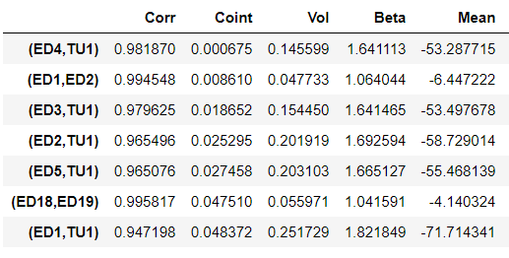

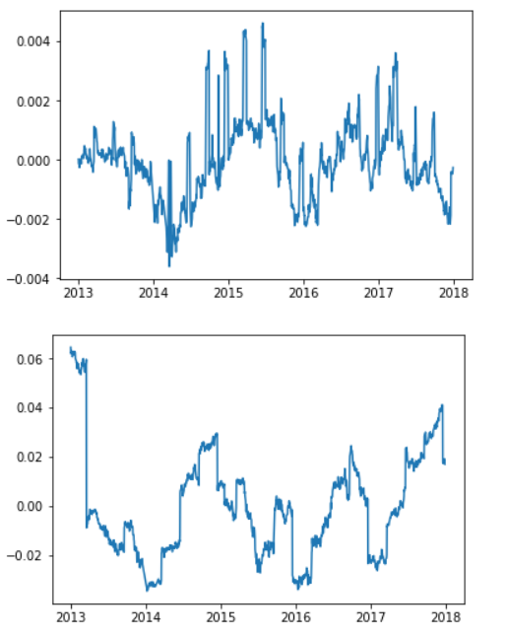

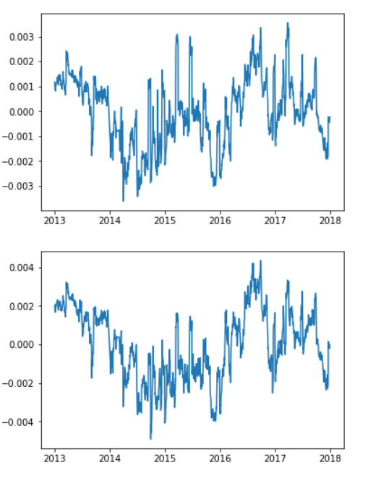

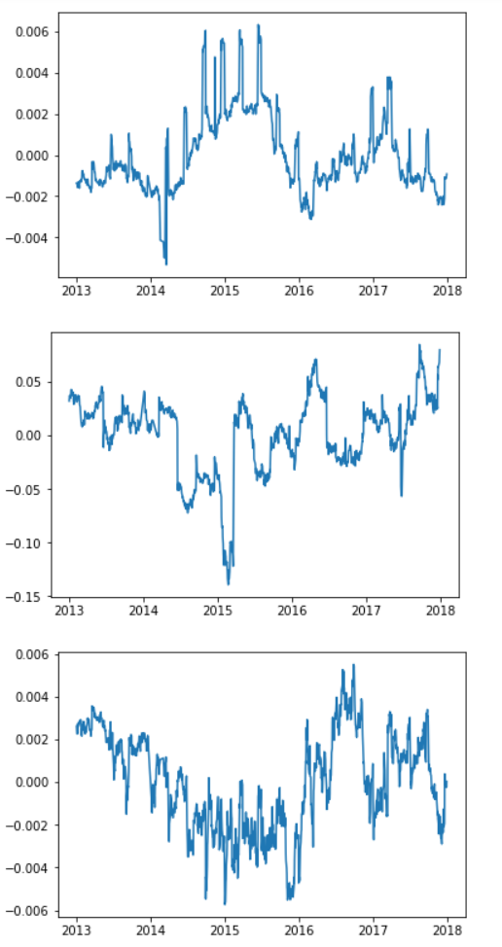

**Chapter 4: Trading Rules Design**

After I finished pair screening, I was going to design my trading rules. To design effective trading rules, I want to answer 5 questions in the design.

How should we allocate capital among selected pairs?

When should we open a position?

When should we close a position?

When should we cut a position?

How do transaction costs influence our result?

For the first question, we haves to ways to select. Firstly, the very simplest method is allocating them equally among all pairs. Secondly, we allocate them proportional to the dollar volatility. We tried both ways and results showed that the second one is better.

Then we set up rules for opening, closing and cutting a position. We open a position when residuals cross $α_{1}*vol$. We close a position when residuals go back to $α_{2}*vol$. We cut a position when residuals reach $α_{3}*vol$. Notice our pair trading based on the mean reversion of residuals. So theoretically, we have $α_{2}< α_{1}< α_{3}$. To decide these three parameters, we run our in-sample portfolio with different parameters combination. We choose parameters by comparing Pnl, trade frequency and hit ratio. Basically we want our Pnl and hit ratio to be high and trade frequency in a reasonable range. On the one hand, we don’t want to trade too frequently, resulting in low profit and high costs. On the other hand, wo don’t want to trade too unfrequently, with each trade a very high profit. That makes us burden too much risk.

To see the influence of transaction costs, we decided transaction cost to be 7 $/trade + 0.00221 $/share. The cost rule is something used in U.S. stock market.

When we don’t consider transaction cost, the summary will be as following.

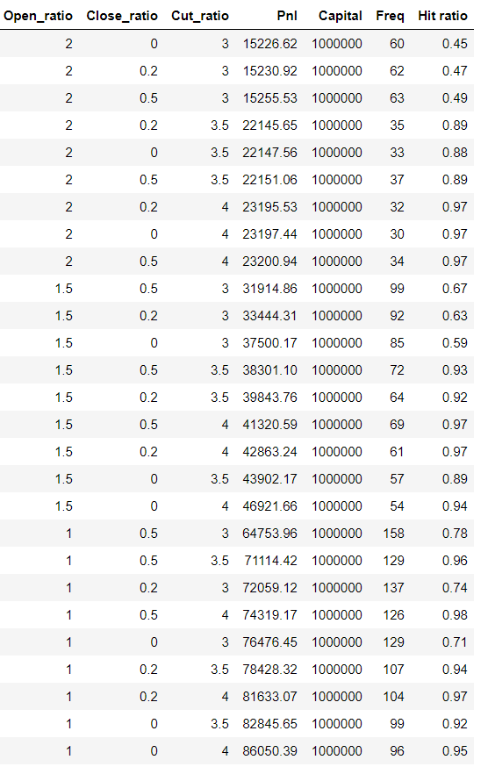

When we consider transaction cost, the summary is as following.

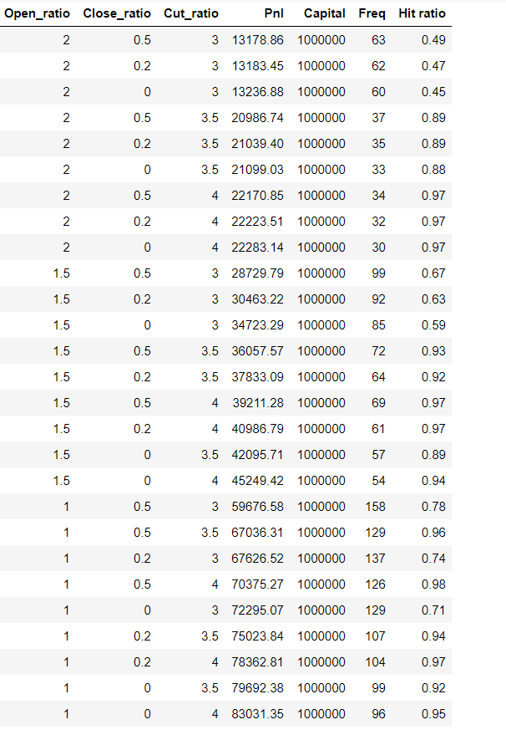

We can see transaction cost has little influence in our project, reducing profit by less than 5%. And it doesn’t influence our choice of parameters. To be closer to reality, we decide to do this project with transaction cost. We choose our parameters combination to be (1, 0, 4), which gives us higher Pnl and hit ratio with reasonable frequency.

Summary for these pairs and an example of hit map is showed here.

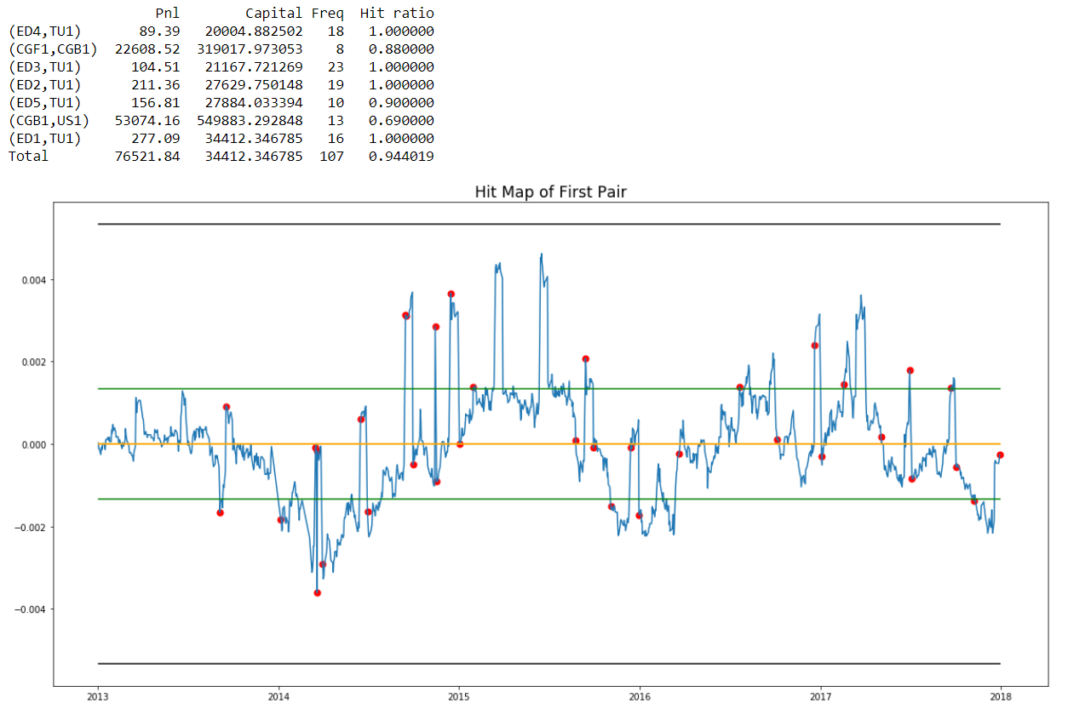

**Chapter 5: Out of Sample Test**

Now we have trading rules. First we allocate capital among selected pairs proportional to dollar volatility. Second our trading cost is 7 $/trade and 0.00221 $/share. Third we choose to open a position when residual cross one volatility, close a position when residual go back to mean and cut a position when residual reach four volatility. We use these rules to test out of sample. The summary is as following.

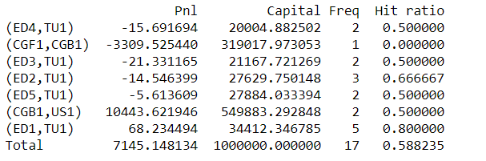

Performance is bad.

The reason for bad performance is cointegration failure out of sample.

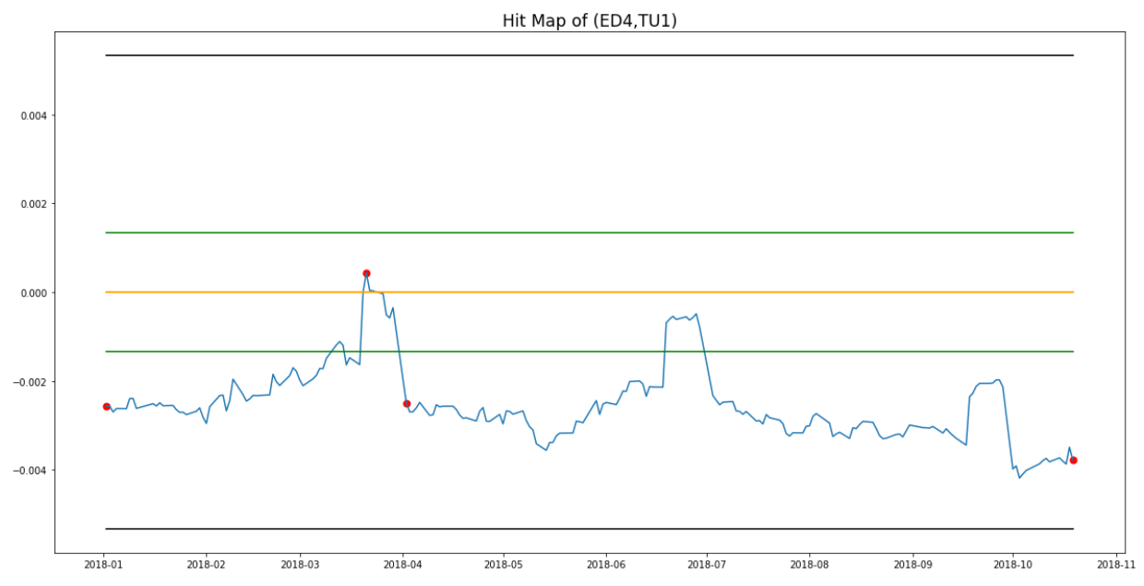

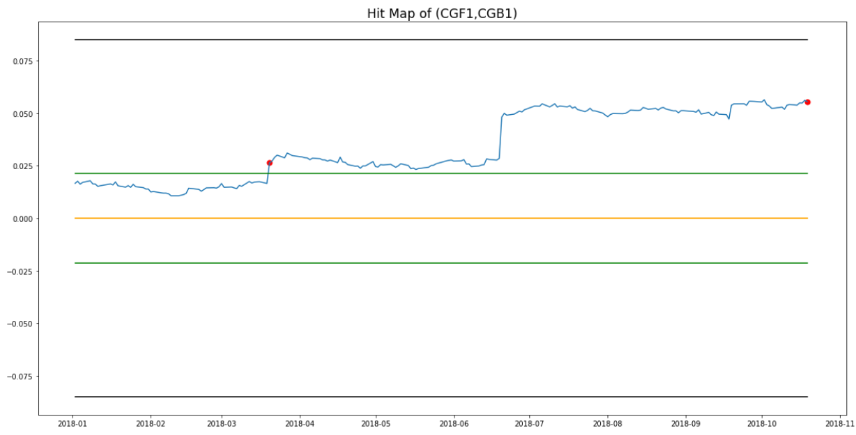

Above are examples for cointegration failure.

Why cointegration fails?

I think the reason is in sample cointegration result is too good and volatility is too small. When it goes out of sample. A VERY LITTLE deviation can change whole story.

Notice we still have some good pairs.

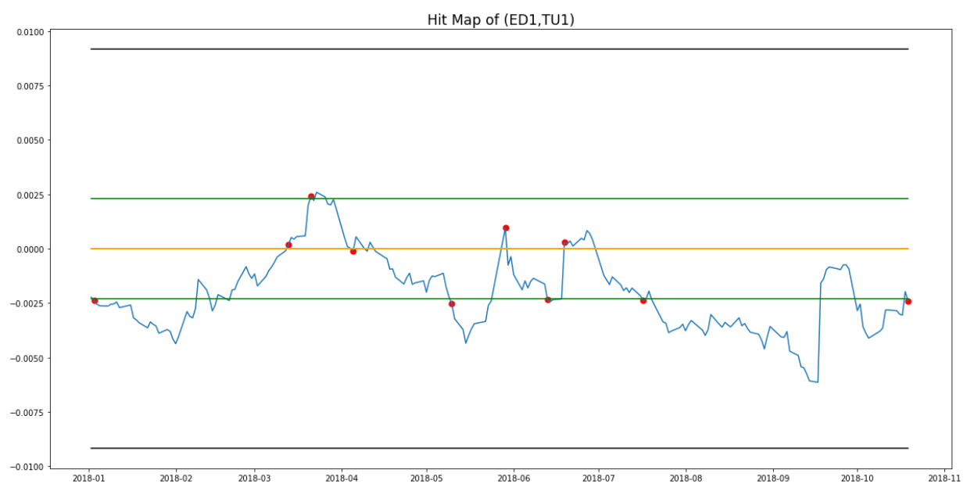

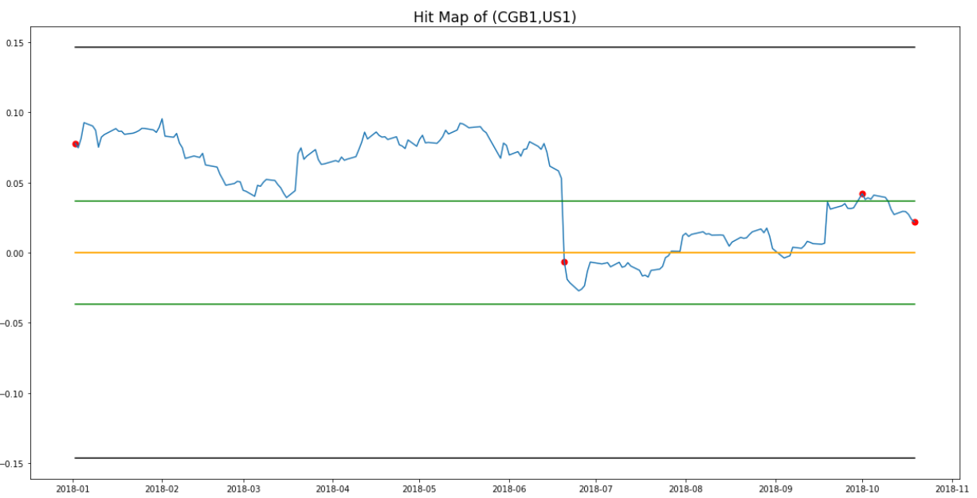

**Chapter 6: Possible Improvements in Future**

Although the out of sample performance is not very well, this project is still a good practice of pair trading. To obtain better result, I think I can improve in three ways.

First, I can choose a bigger instruments pool. A bigger universe gives me higher chance to select better pairs.

Second, I can use high frequency data instead of daily data. In this project, Annualized return in daily data is too low, as only a few trades happen in a year. Using high frequency data is more like the reality. Additionally, influence of transaction cost is more significant in high-frequency trading. What’s more important is cointegration will be more consistent using high frequency data because the trend in several weeks or several months will not have a very big influence like yearly data.

Third, using rolling basis trading may give us better result.